Homework1-(XinyuLi)

1. Cars

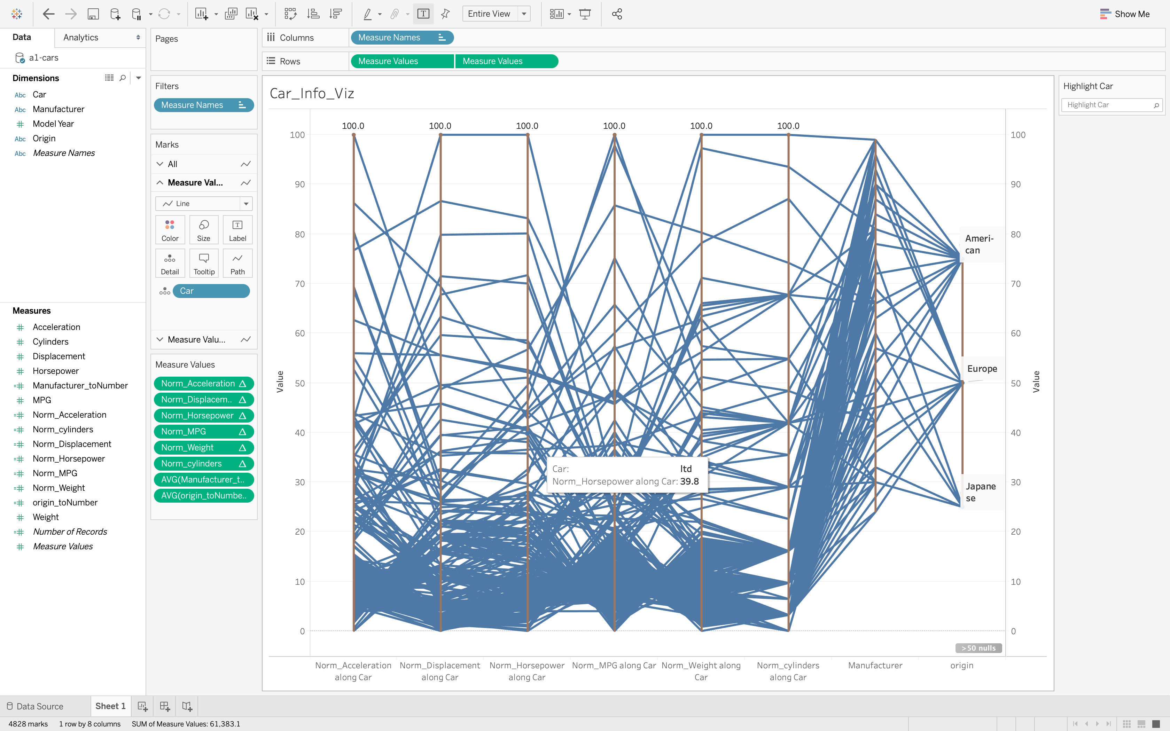

Insight: In this parallel visualization, multiple dimensions are mapped and normalized to axis with same length (0-100). From this figure, we can see most cars with low weight have low horsepower and low MPG.

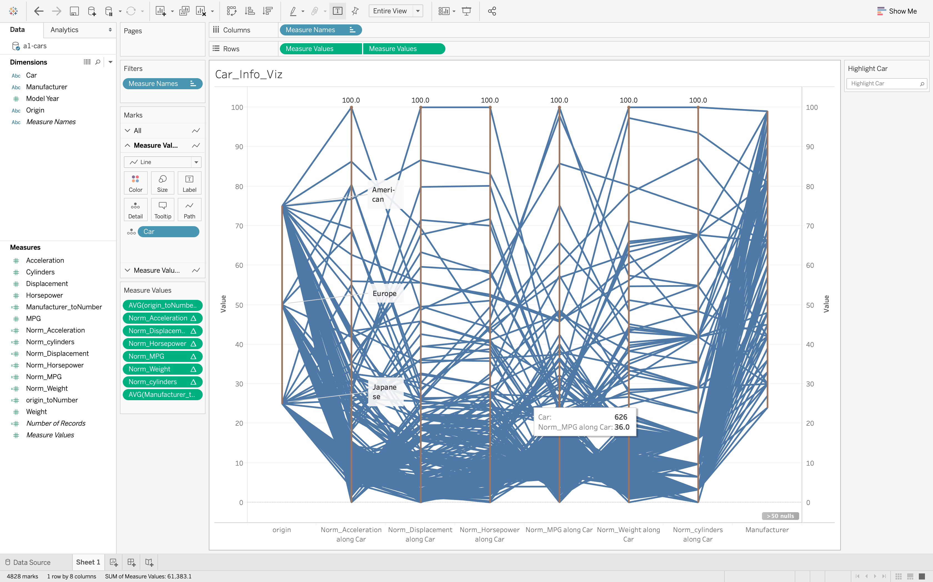

Change the order of axis, we can see that most Japanese cars have less acceleration than European cars than American cars.

1. Cereals

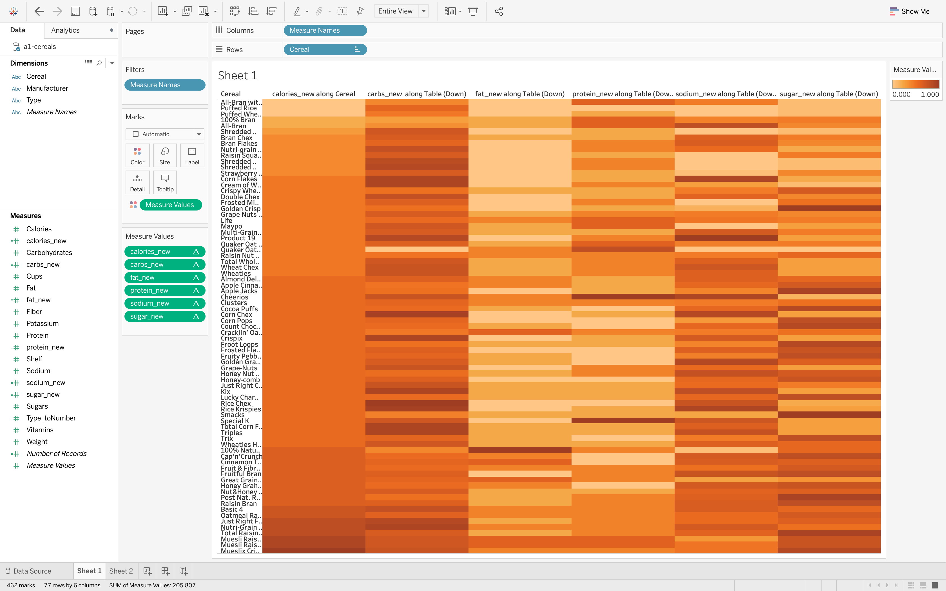

This cereals table is visualized with heatmap. We rearrange the records by increasing order of calories(1st column). As we could see from heatmap that overall, colors are darker on bottom than on top. That means, cereals with lower calories are lower in fat, carbs and protein; cereals with higher calories are higher in fat, carbs and protein.

1. Film

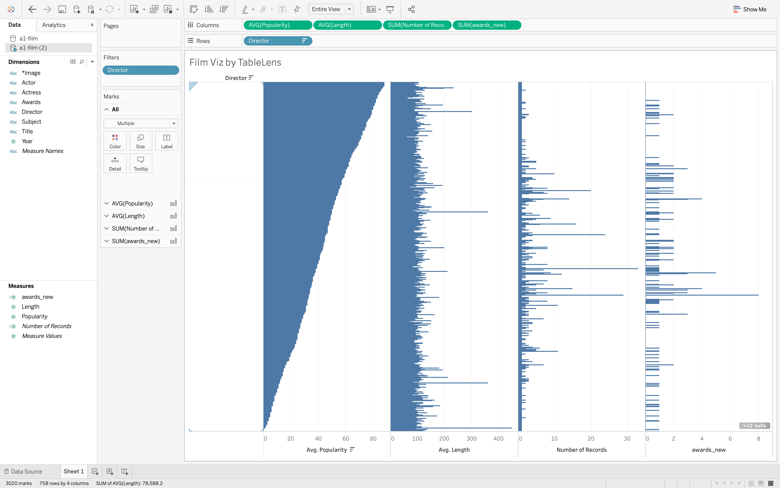

Film table is visualized by table lens and data entries are sorted by their average popularities of director decreasingly. Spikes in each column indicate some distinguished records in number of records and number of awards received of a director. In the figure above, spikes usually take place along some director which means directors with more products usually have bigger change to win awards. It can also be inferred from figure that average length does not have relations to the product of a movie.

1. Grocery

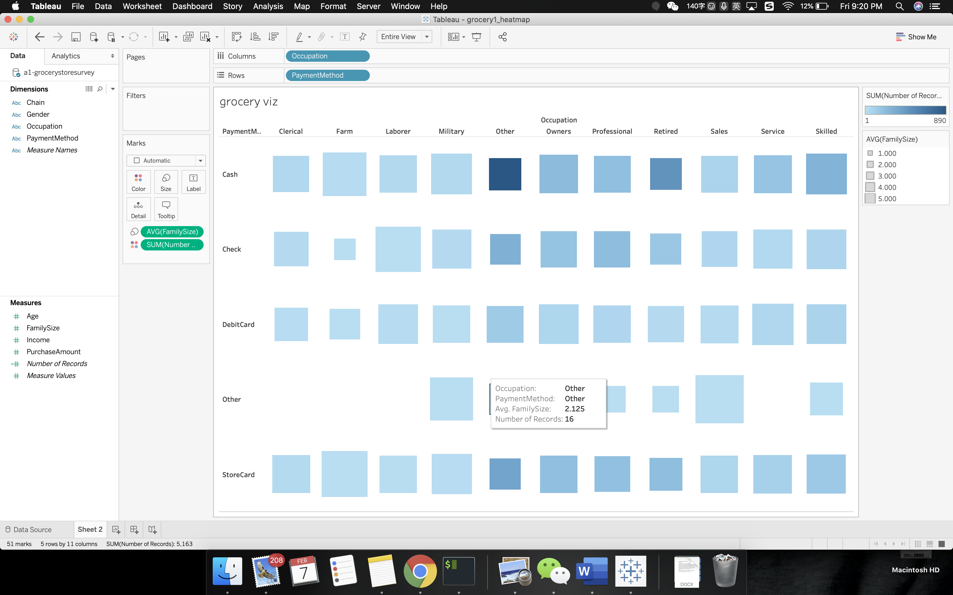

Grocery table is implemented by an advanced heatmap combined with glyph. Its column is payment method and row occupation. Size of each square corresponds to family size and the darker the color indicates more popular this pattern is (illustrated by more number of records). From the figure we can see that most family are of size 2 to 3. Cash payment still dominates the payment. Occupation owners usually have bigger family size and pays more in grocery stores.

1. Mutual fund

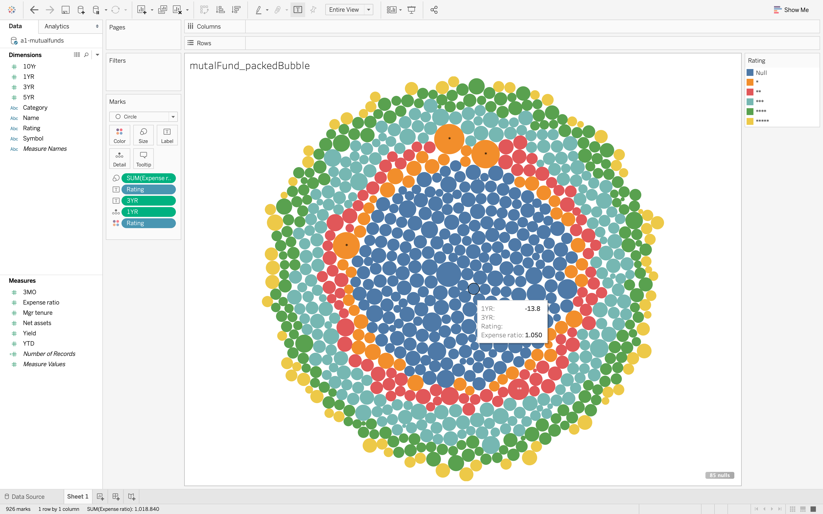

Mutual fund table is visualized by packed bubbles where size indicates expense and color indicate rating (closer to circle, lower the rate). From the figure, we can see that there are very few funds that have 5 stars while most of them are null stars. High rating funds are usually low in expense. Most one star rating funds are high in expense(Big size in bubble).